**RESTAURANT BILLING MANAGEMENT SOFTWARE**

**:TEAM MEMBERS:**

**BHAVESH MALI : 60003200115**

**RUSHI KANTODE : 60003200117**

**NIMESH SAKHIYA : 60003200119**

* **PROBLEM STATEMENT:**

We have build a restaurant billing management software that has several features such as:

1. Generate Invoice.

2. Show all Invoices.

3. Show all Invoices.

4. Clear all Invoices.

Description:-

We have created an C language program to manage the bills that an restaurant manager uses to manage and maintain an record of all the bills of customers. This program is an application of concept of File Handling in C language to input and store the data taken from user in form text file for future use as the manager can maintain an record the data of customers using this program. In this program we have included feature like generate a new Invoice , show all the previously saved Invoices, to search any Invoice by just entering the name and surname of the customer and an feature to clear all the previously saved bills. The program takes input as name of the customer, food item name, quantity of particular food item, amount of individual unit and presents an complete print ready bill data in an tabular form including 10%discount and GST@18% on total amount and calculates the final amount to be paid at the last. In such manner our program helps the manager to create the bill conveniently and manage all the saved bills for record purpose.

* **CODE:**

#include<stdio.h>

#include<string.h>

#include<stdlib.h>

struct items

{

char item[20];

float price;

int qty;

};

struct orders

{

char customerFirstName[20];

char customerLastName[20];

char date[30];

int noOfItems;

struct items itm[50];

};

void generateBillHeader(char firtsName[20],char lastName[20],char date[30]){

printf("\n\n");

printf("\t RNB. Restaurant");

printf("\n\t=======================");

printf("\nDate:%s",date);

printf("\nInvoice for: %s %s",firtsName,lastName);

printf("\n");

printf("======================================");

printf("\nItem\t\t");

printf("Qty\t\t");

printf("Total\t\t");

printf("\n======================================");

printf("\n\n");

}

void generateBillBody(char item[20],int Qty,float price ){

printf("%s\t\t",item);

printf("%d\t\t",Qty);

printf("%0.2f\t\t",price);

printf("\n");

}

void generateBillFooter(float total){

printf("\n");

float tax = 0.18*total;

float dis = 0.1*total;

float netTotal = total-dis +tax;

printf("======================================");

printf("\nSub Total \t\t\t%0.2f",total);

printf("\nDiscount @10%s\t\t\t%0.2f","%",dis);

printf("\nGST @18%s\t\t\t%0.2f","%",tax);

printf("\n======================================");

printf("\nNet Total\t\t\t%0.2f",netTotal);

printf("\n======================================");

}

int main(){

int opt,n;

char saveBill,flag='y';

char firstName[20];

char lastName[20];

struct orders ord;

struct orders order;

FILE *fp;

// Dashboard for user

while(flag =='y'){

float total=0;

int invoiceFound=0;

system("cls");

printf("\n");

printf("\n");

printf("\t==========RNB. Restaurant==========");

printf("\n\n Please select your prefered opton: ");

printf("\n 1.Generate Invoice");

printf("\n 2.Show All Invoices");

printf("\n 3.Search Invoice");

printf("\n 4.Clear all Invoices");

printf("\n 5.Exit");

printf("\n");

printf("\n");

printf("Your Choice: ");

scanf(" %d",&opt);

switch (opt){

case 1:

system("cls");

printf("Please enter the name of the costumer: \t");

scanf(" %s",&ord.customerFirstName);

scanf("%s",&ord.customerLastName);

strcpy(ord.date,_DATE_);

printf("Please enter the number of items: \t");

scanf(" %d",&n);

ord.noOfItems=n;

for (int i = 0; i < n; i++)

{

printf("\nEnter the item no %d: \t\t\t",i+1);

scanf(" %s",&ord.itm[i].item);

printf("Enter the quantity of item: \t\t");

scanf("%d",&ord.itm[i].qty);

printf("Enter the unit price: \t\t\t");

scanf("%f",&ord.itm[i].price);

}

generateBillHeader(ord.customerFirstName,ord.customerLastName,ord.date);

for(int i=0;i<ord.noOfItems;i++){

total += ord.itm[i].qty*ord.itm[i].price;

generateBillBody(ord.itm[i].item,ord.itm[i].qty,ord.itm[i].price);

}

generateBillFooter(total);

printf("\n\nDo you want to save the invoice[y/n]:\t");

scanf("%s",&saveBill);

if(saveBill=='y'){

fp=fopen("RestaurantBill.txt","a+");

fwrite(&ord,sizeof(struct orders),1,fp); // fwrite(name of structure, size of structure, how many times you wanna save it, file pointer where array will be stored)

if(fwrite!=0){

printf("\nSuccessfully Saved");

}

else{

printf("\nError Saving");

}

fclose(fp);

}

break;

case 2:

system("cls");

fp=fopen("RestaurantBill.txt","r");

printf("\n*Your Previous Invoices\n");

while (fread(&order,sizeof(struct orders),1,fp)){

float total1=0;

generateBillHeader(order.customerFirstName,order.customerLastName,order.date);

for(int i=0;i<order.noOfItems;i++){

total1 = total1 + order.itm[i].qty*order.itm[i].price;

generateBillBody(order.itm[i].item,order.itm[i].qty,order.itm[i].price);

}

generateBillFooter(total1);

}

fclose(fp);

break;

case 3:

system("cls");

printf("Enter the name of the customer: ");

scanf("%s",&firstName);

scanf("%s",&lastName);

system("cls");

fp=fopen("RestaurantBill.txt","r");

printf("\n *Invoices for %s %s *\n",firstName,lastName);

while (fread(&order,sizeof(struct orders),1,fp)){

float total1=0;

if((strcmp(firstName,order.customerFirstName)&&strcmp(lastName,order.customerLastName))==0){

generateBillHeader(order.customerFirstName,order.customerLastName,order.date);

for(int i=0;i<order.noOfItems;i++){

total1 += order.itm[i].qty*order.itm[i].price;

generateBillBody(order.itm[i].item,order.itm[i].qty,order.itm[i].price);

}

generateBillFooter(total1);

invoiceFound=1;

}

}

fclose(fp);

if(invoiceFound==0){

printf("\nSorry No Invoice for %s %s exists \n",firstName,lastName);

printf("\n\n");

}

break;

case 4:

system("cls");

fp=fopen("RestaurantBill.txt","w");

printf("All Invoices Cleared");

fclose(fp);

break;

case 5:

printf("\n\t\tBye Bye :-)\n\n");

exit(0);

break;

default:

printf("\nSorry Invalid Option\n");

break;

}

printf("\n\nDo you want to perform another operation?[y/n]\t");

scanf("%s",&flag);

}

printf("\n\n");

return 0;

}

* SCREENSHOTS:-

1.Genrate invoice output:

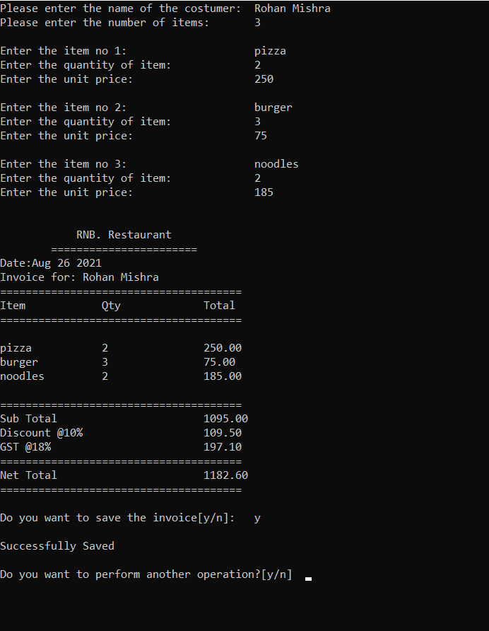

2. Show all invoices :-

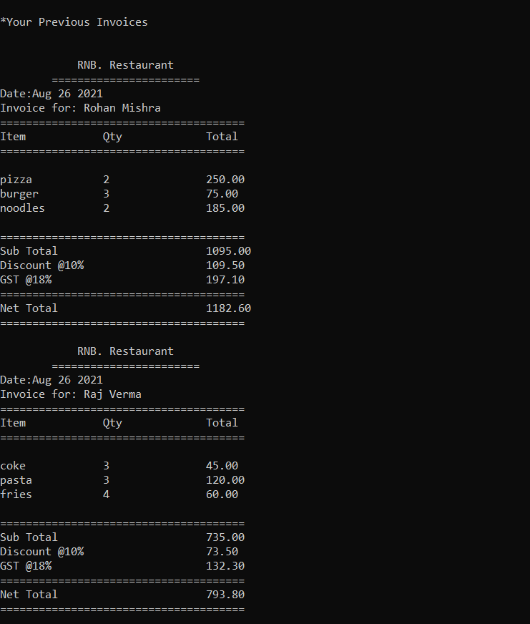

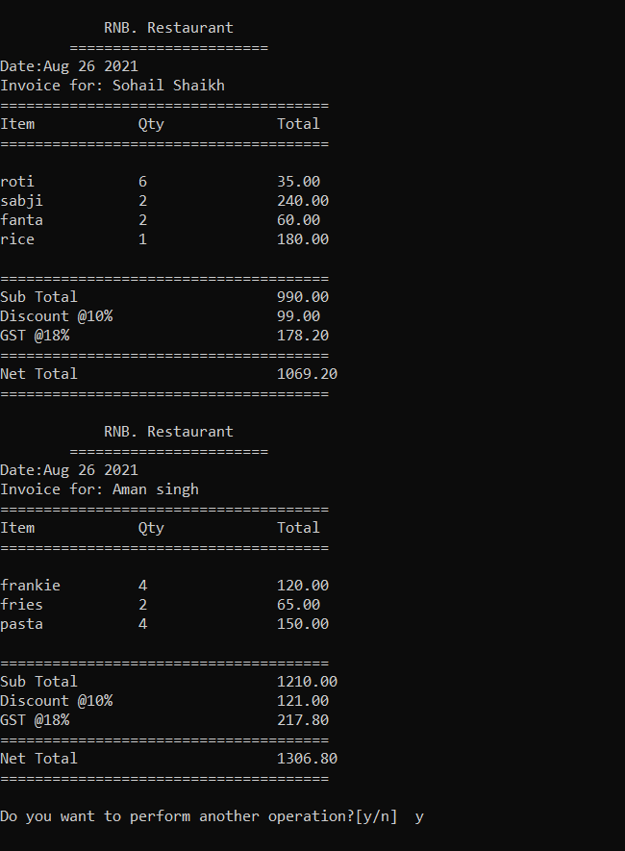

3. Search Invoices output:-

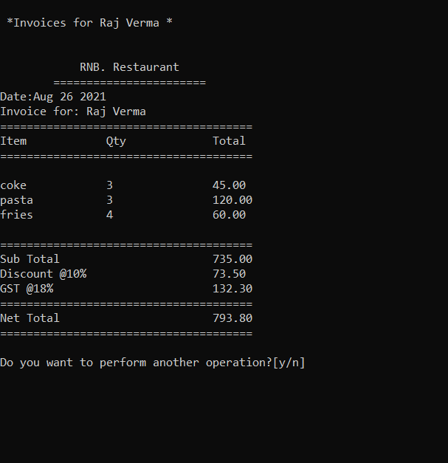

4. Clear all Invoices output:-

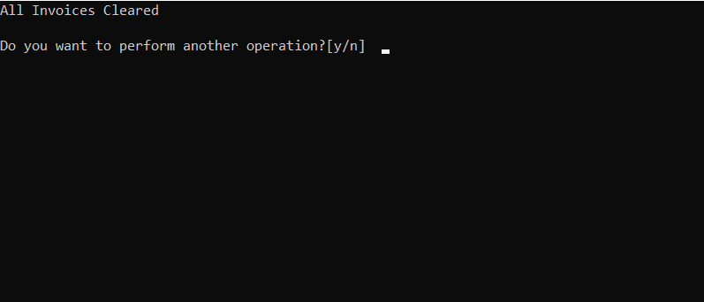

**😊THANK YOU😊**